**Comparing Means, samples t-tests, and P-values in SPSS**

**Vincent Were**

**Comparing Means, samples t-tests, and P-values in SPSS**

**Introduction**

In many situations, you will wish to compare the means, samples t-tests, and p-values of two populations or samples in statistics. The method one employs to calculate and compare the mean relies on the kind of data an individual has and how it is organized. A statistical test t-test is used to compare the means of the two groups. It frequently appears in hypothesis testing. While the P-value calculates the likelihood of getting outcomes observed, presuming that the null hypothesis is correct ( Park,2019).

**1a)** **Compare Means function on the Body Image and Self Esteem variables**

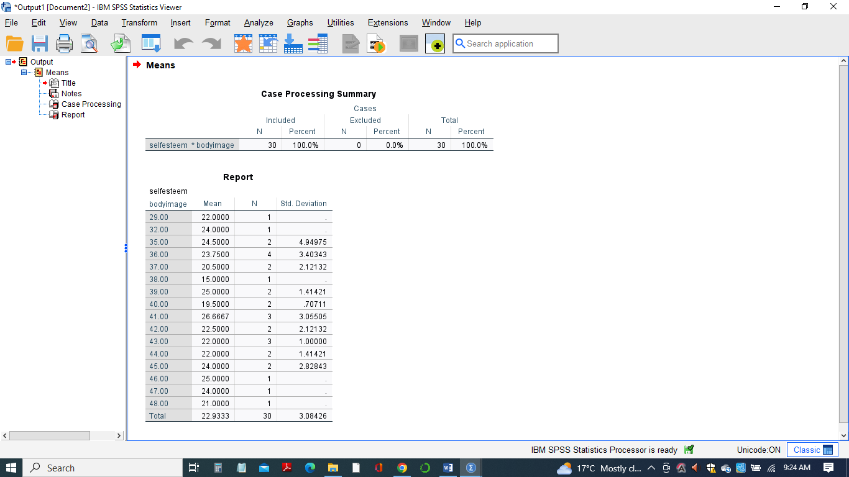

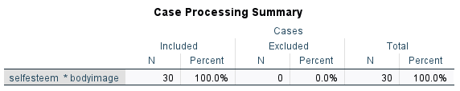

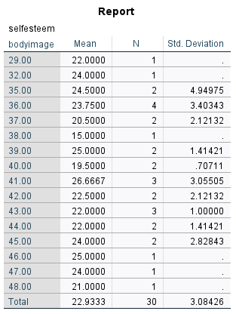

**1b)** **The differences in means comparisons**

Using the compare means function between the Body Image and Self Esteem variableson the Food Consumption SPSS data set. Body Image is placed as the independent variable, while the Self Esteem as the dependent variable for analysis. Among the total N=30 Samples, cases included were 30 samples translated to 1000%, while the cases excluded were zero 0.

From the total 30 samples, the least average was 15.0000, and the highest mean average was 26.6667. Secondly, the lowest body image, 29.00, has a mean value of 22.0000, while the highest Body Image variable, 48.00, has an average mean value of 22.9333. There were nearly the same mean average among the 32.00, 35.00, and 47.00 Body Image variables. The 32.00 and 47.00 Body Image variables have the same mean average values. The standard deviations within the Body Image variables are not relatively close (Liang,2019). Finally, among the total samples, the difference in mean or average of the total 30 samples (*n* = 30) was just about 2.0000.

**2a) (i)** **Independent samples t-tests between Dieting Status and Body Image variables**

Body image is the test variable, while Dieting status is the grouping variable.

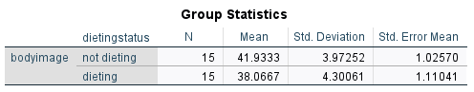

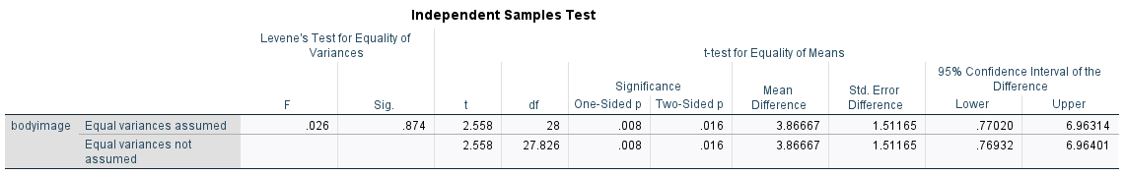

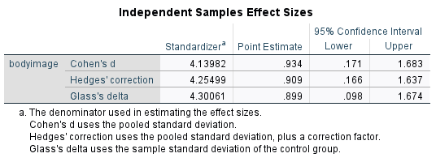

**2a) (ii)** **Independent samples t-tests between Dieting Status and Self-Esteem variables**

Self-esteem is the test Variable, while Dieting Status is the grouping Variable.

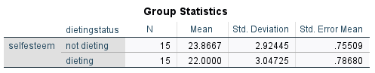

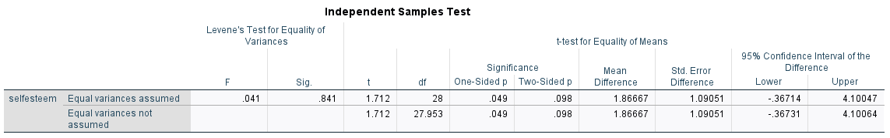

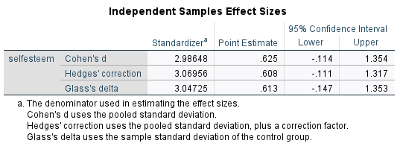

**2b)(i)** **P-values and the relationship between Dieting status and Body image**

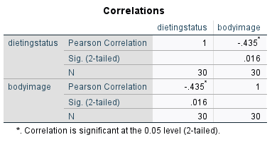

The test is significant since the p-value of 0.016 (p=0.016) is less than the 0.05 two-tailed significant level; thus, there is a significant relationship between the Dieting status and the Body Image variables.

**2b)(ii)** **P-values and the relationship between Dieting Status and Self-esteem**

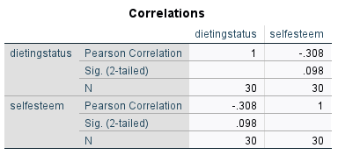

The p-value of 0.098 (p=0.098) suggests that the test is insignificant. This is because the p-value obtained is greater than the 0.05 two-tailed significant level; thus, there is no significant relationship between the Dieting Status and Self-esteem variables.

**3a)** **Means for Consumption1, Consumption2, Mood1, and Mood2**

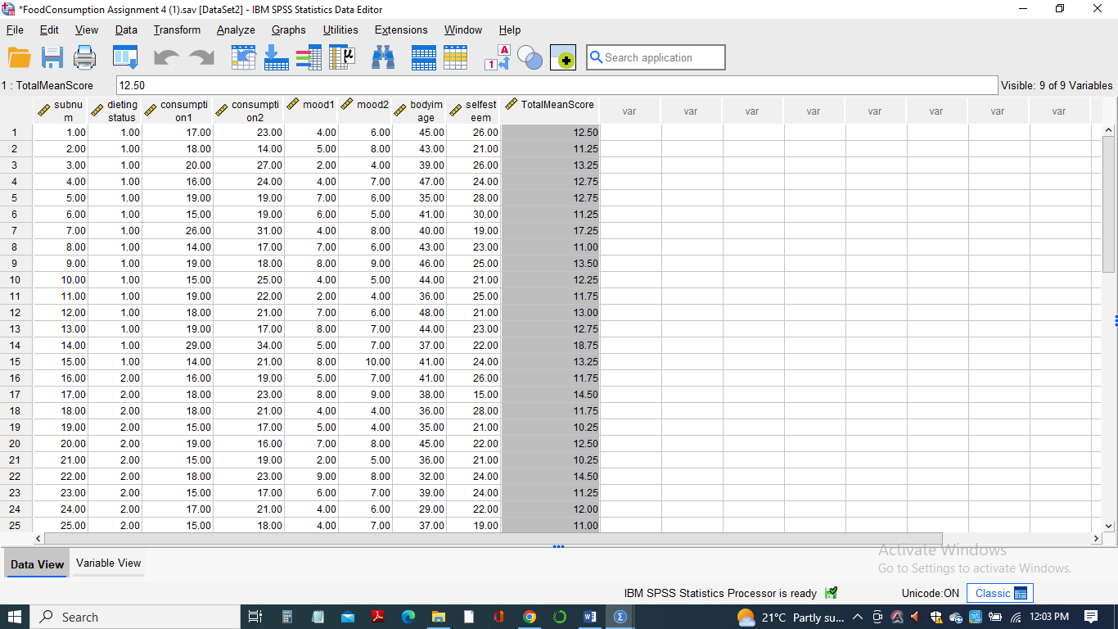

**3b)** **How scores on Consumption and Mood changed from Time 1 to Time 2**

Using a new variable named TotalMeanScore, the means of theConsumption1, Consumption2,Mood1, and Mood2 variables are computed, and the mean score for Consumption and Mood is found to have slightly increased from the first *Time 1* session to the second session *Time 2* in both cases.

**3c)** **Dependent samples t-tests on the Consumption variables and the Mood variables**

***3c)(i)******Dependent samples t-tests on the Consumption1 and Mood1 variables***

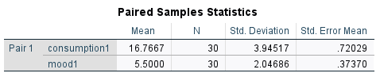

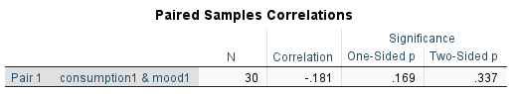

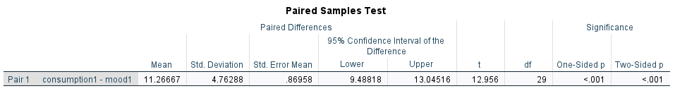

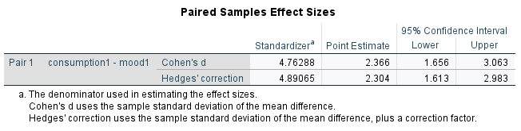

***3c)(ii)******Dependent samples t-tests on the Consumption2 and Mood2 variables***

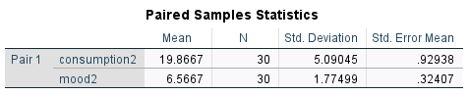

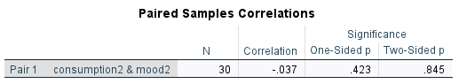

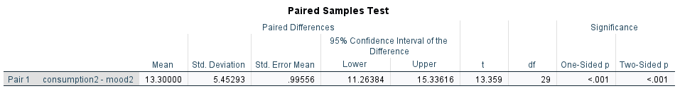

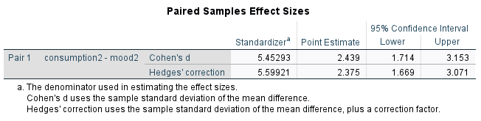

**3d)** **P-values on the Consumption and Mood variables and conclusion about the changes in consumption and mood.**

***3d(i) P-value of Consumption1 and Mood1***

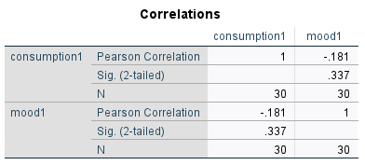

The p-value of 0.337(p=0.337) suggests that the test is insignificant. This is because the p-value obtained is greater than the 0.05 two-tailed significant level; thus, there is no significant relationship between the Consumption1 and Mood1 variables.

***3d(ii P-value of Consumption2 and Mood2***

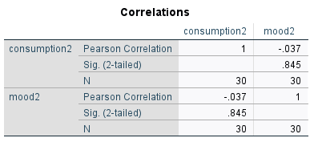

Also, in the second case, the p-value of 0.845 (p=0.845) suggests that the test is insignificant. This is because the p-value is greater than the 0.05 two-tailed significant level; thus, there is no significant relationship between the Consumption2 and Mood2 variables.

In conclusion, the p-value between consumption and mood variables increased from 0.337 to 0.845 in the two sessions amongst the 30 participants.

**4a)** **Research hypothesis (unrelated to the Food Consumption dataset)**

A research hypothesis is assessed using a dependent samples t-test on a hypothetical data set containing the height and weight of 10 individuals. The heights and weights Variables are used as independent variables, and the entry values as the dependent variables for both cases.

**4b)** **Dependent samples t-test on the hypothesis data in SPSS**

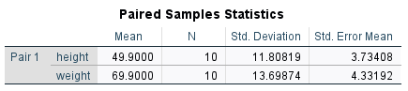

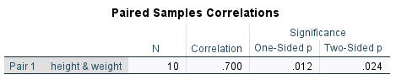

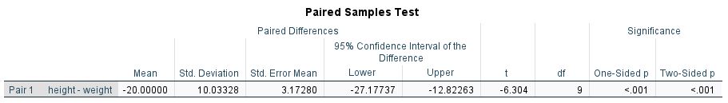

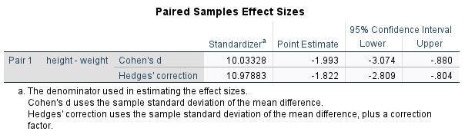

**4c) Description of the research hypothesis and support from the hypothetical data**

From the hypothetical data containing the height and weight Variables, it is noted that the dependent t-test can look for "differences" between means when the 10 participants are measured on the same dependent variable under different conditions, thereby supporting the research hypothesis. In addition, the one-sided p-value of 0.012 (p=0.012) and the two-sided p-value of 0.024(p=0.024) are less than the 0.05 two-tailed significant level suggesting the test is significant; thus, there is a significant relationship between the height and the weight variables (Cleophas et al.,2010).

**Conclusion**

In conclusion, the Compare Means procedure might be helpful when comparing variations in descriptive statistics across one or more factors or categorical variables. In addition, two tables will be produced by the Compare Means procedures: the Case Processing Summary, which includes details about the number of valid cases used to generate the statistics, and the Report table, which includes the descriptive statistics themselves (Plonsky,2015). Therefore when comparing multiple numerical variables to one or more categorical variables, Compare Means is the method of choice even when summarizing numerical variables simultaneously across categories; it is helpful (Orcan,2020).

**References**

Cleophas, T. J., & Zwinderman, A. H. (2010). Unpaired Continuous Data (Unpaired t-Tests, Mann–Whitney)(20 Patients). In *SPSS for Starters* (pp. 11–13). Springer, Dordrecht.

Liang, G., Fu, W., & Wang, K. (2019). Analysis of t-test misuses and SPSS operations in medical research papers. *Burns & trauma*, *7*.

Or, F. (2020). Parametric or non-parametric: Skewness to test normality for mean comparison. *International Journal of Assessment Tools in Education*, *7*(2), 255-265.

Park, H. M. (2019). Comparing group means t-tests and one-way ANOVA using Stata, SAS, R, and SPSS.

Plonsky, L. (2015). Statistical power, p values, descriptive statistics, and effect sizes: A “back-to-basics” approach to advancing quantitative methods in L2 research. *Advancing quantitative methods in second language research*, pp. 23–45.